Post processing of Pseudo-spectral Code MagIC.

Spherical Harmonic function as choice for expansion inf colatitude $θ$ and longitude $ϕ$.

$Y_{l}^{m}(θ,ϕ)$ = $P_{l}^{m}(cosθ)e^{im ϕ}$

After normalization we get

$$Y_{l}^{m}\left(θ,ϕ\right)= {\left(\frac{(2l+1)}{4π}\frac{\left(l-\left|m\right|\right)!}{\left(l+\left|m\right|\right)!}\right)}^{1/2} P_{l}^{m}(cosθ)e^{im ϕ}$$

Here, l is the spherical harmonic degree and m is the order in the longitudinal direction. l controls the nodes along the latitude and m controls the azimuthal variation. The FFT can only be performed in the azimuthal direction.

The l values relate to spherical harmonic length scale as outlines in Nicoski et al.(2024). 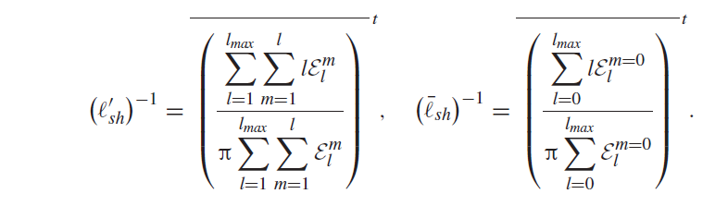

l=0,1,2,3,4…….. upto maximum l. m=-l,-l+1,-l+2…..l-2,l-1,l so for each l there are 2l+1 values of m. However, we only store m=0,1,2,….l as negative values can be obtained by taking complex conjugate.

The storage of these (l,m) pairs is crucial. Lets have a list with maximum value of l resolved upto l_max so

m=0 => l=0, 1, 2, 3,……… l_max

m=1 => l=0, 1, 2, 3,…….l_max-1

m=2 => l=0, 1, 2, 3,……l_max-2

m=3 => l=0, 1, 2, 3,…..l_max-3

m=4 => l=0, 1, 2, 3,….l_max-4

……………….

……………..

………….

……….

…….

…..

…

.

m=l_max

So for each m block there are certain values of l with m=0 block having the highest number. These combinations of (l,m) can be arranged in an LM array as follows.



LM=[(0,0),(1,0),(2,0),….(l_max,0), (1,1),(2,1),...(l_max-1,1)……… (l_max,l_max)]

Now, each entry in the list can be given an index in order they appear as follows

LM=[0, 1, 2, 3, 4, ……………………………(max LM pairs -1)]

MagIC potential files outputs the values of potential in this LM arrays therefore its also crucial to decode the LM array back to l and m values. We do it using the following routine:

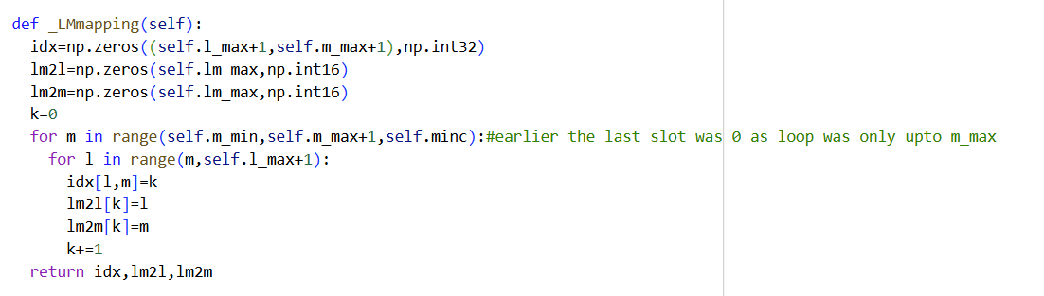

This returns idx array which is a 2D array of the LM values corresponding to LM value in the list, lm2l and lm2m gives the corresponding l and m values.

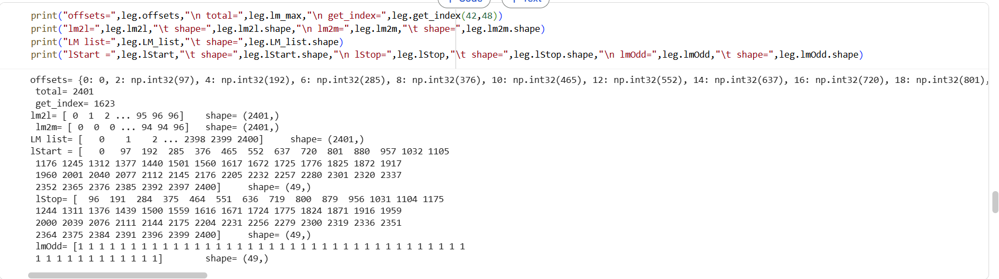

Here, we output for one of the potential files where l_max=96. The total combination of LM is 2401, the LM list goes from 0 to 2400(since python is 0 based indexing). Similarly, lm2l shows l values from 0 to 96. The m values are repeated according to each l values and occur at difference of 2(minc=2), following azimuthal symmetry. The last value of lm2m has only single entry as 96 since for m_max block only needs one member that is l_max.